Social Studies 10 Mr. Champion
Personalities and Power
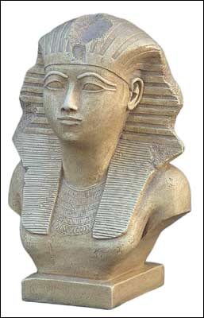
HATSHEPSUT (1479 BCE-1457 BCE)
Page 85
How did she come to power?

How and why did she follow the customs of male pharaohs?

What things did she do that would make historians consider her a strong ruler?

Why is the end of her history considered so mysterious?

RAMSES II (1279 BCE-1213 BCE)
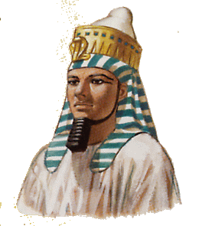
Page 86
Why was Ramses referred to as “The Great”?

What did Ramses do to ensure his legacy?

Why might he be considered the “most colorful” figures of the ancient world?

Do you think he deserves to be called “Ramses the Great”? Why or why not?

