The Great Depression hit Canada the hardest

Mar 28, 2013 Waterloo Region Record
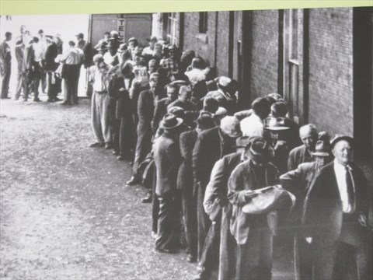
Unemployed men line up outside a soup kitchen in Toronto during the Great Depression. - News services file photo
The Great Depression devastated many economies. But one country arguably suffered more than any other: Canada.
By the time its economy reached bottom in 1932, Canada had suffered a staggering decline of 34.8 per cent in per capita gross domestic product. No other developed nation was as hard-hit.
Canada was, and still is, a country dependent on trade. In the 1920s, commodities — such as wheat — and lumber products, including newsprint, were particularly important. In 1930, U.S. president Herbert Hoover signed into law the Smoot-Hawley Tariff Act, which raised duties on many imports to historically high levels. This led to retaliatory tariffs and a drastic reduction of trade around the world.
It was particularly harmful to Canada, America’s largest trading partner, where export prices plummeted. The price of lumber fell 32 per cent from 1929 to 1932, and cattle prices declined 63 per cent. Smoot-Hawley sent major Canadian pulp and paper companies into bankruptcy. Canadian automakers saw their exports collapse to 13,000 vehicles in 1931 from 102,000 in 1929. Manufacturing, in general, declined more than 50 per cent.
Unemployment reached an average of 32 per cent in Canadian cities. In Windsor, Ont., it reached 50 per cent. In the Maritime provinces, unemployment for ordinary labourers hit 60 per cent.
The human toll was greatest on the Canadian prairies, which suffered not just from the trade wars but from drought, deprivation and plagues of grasshoppers. By the time the Depression was over, one in 12 people had left the region for good, and much of the province of Saskatchewan had been reduced to a wasteland ravaged by natural disasters. In tiny Minton, most of the population of 890 depended on government relief and charity; even the town’s chickens had to depend on relief feed.
Yet for all the suffering, Canadians never embraced the kind of government intervention into the economy that the U.S. did. A short-lived attempt by prime minister R.B. Bennett to copy Franklin Roosevelt’s New Deal was ultimately struck down by the Privy Council in London, which was still Canada’s ultimate Supreme Court.
And despite the human devastation, Canadians never turned in large numbers to “-isms” — communism and socialism — preferring to keep their traditional political parties. True, in 1935 the people of Alberta elected the Social Credit Party, which had unusual (one might say radical) views on monetary policy. But this was an exception.
Instead, Canadians muddled through the crisis with a makeshift combination of private and public charity. Private citizens in wealthier provinces recognized the plight of Saskatchewan and sent hundreds of carloads of fruit, vegetables and clothing westward. Bennett made a habit of sending money from his personal fortune to those who wrote to him pleading for help.
The government did construct relief camps for unemployed men, providing some low-wage work and alleviating the threat of large numbers of jobless in the cities. The state also used force to suppress social discontent, most famously in 1935, when the unemployed organized an “On-to-Ottawa Trek” from the west. The movement got as far as Regina when it was met by the Royal Canadian Mounted Police and local officers. The resulting clash left one police officer dead; a trekker died of wounds soon thereafter. The movement soon fizzled out.
In general, Canadians handled the Great Depression with a minimum of drama. Life was tough in a cold country, and people were accustomed to dealing with adversity. The economy picked up as the Second World War set in, and the phlegmatic nature of Canadians played no small part in the recovery.
As the Canadian historian James Gray observed, the Great Depression “brought out more of the best than it did the worst in people,” offering a reminder that “people, if left alone, tend to work out their own problems for themselves; that expert advice, particularly in economic matters, is most useful when it is completely ignored.”
Joe Martin is the director of Canadian business history at the Rotman School of Management, University of Toronto, and is president emeritus of Canada’s History Society. (Bloomberg News)

