Ancient genes reveal first Americans separated and reunited on their way south
IVAN SEMENIUK
PUBLISHED MAY 31, 2018UPDATED MAY 31, 2018
For thousands of years, Indigenous people have occupied the marshy banks of the Detroit River, south of Windsor, Ont., leaving behind artifacts and, in some cases, human remains.
Now, some of those remains have been swept up into a larger story that adds a fascinating new layer of complexity to the emerging picture of how people first settled the New World.
Based on the most extensive genetic survey of early North Americans to date, an international team of researchers has concluded that soon after hunter-gatherers crossed into the continent from Siberia, about 18,000 to 15,000 years ago, they split into two distinct populations. The parallel groups remained in genetic isolation for centuries until they recombined and their offspring populated Central and South America.
If correct, the new interpretation lifts the veil on a remote period in Indigenous history and hints at some of the environmental and social forces that may have been at play as the ancestors of today’s native Americans adapted to new surroundings and changing conditions.
“We’re seeing a lot more movement throughout time than I think people assumed,” said Christiana Scheib, a senior research fellow of ancient DNA at the University of Tartu in Estonia and lead author on the study.
Dr. Scheib, who undertook the study as part of her doctoral research at Cambridge University, assembled DNA evidence from the remains of 91 ancient individuals uncovered in California and Southwestern Ontario. The Ontario samples, including several from the Windsor site, were extracted from teeth that date back as far as 4,200 years ago. Combined with more recent data, the samples proved crucial for discerning a signal in the ancient DNA that studies based on fewer individuals would have not been able to detect.
The DNA show that some of the California samples carry one pattern of telltale genetic variations, while the Ontario group carries another. Both patterns, which Dr. Scheib and her colleagues dubbed “A” and “B,” are equally divergent from the genes of native Siberians. This suggests that a single population migrated from the Old World and then branched into two lineages, which remained apart for up to a few thousand years. Some of the descendants of the B group established themselves in the Great Lakes area, leaving a genetic trace that turned up in burials near Windsor, among other Ontario locations.
But elsewhere, people from the two lineages must have encountered each other and produced children with their distant relatives. As a result, the genetic patterns of both groups are present in the DNA of native Central and South Americans.
“This recombination would have occurred in deep time as well, probably not that long after the glaciers started to recede,” said Genevieve Dewar, a bioarchaeologist at the University of Toronto who led the work on the Ontario samples.
The team proposed four different scenarios for how and where the recombination could have occurred.
The study is the latest to effectively rule out a once widely held view that the first humans to reach North America walked across a land bridge that once connected Alaska and Siberia, and then wandered south through an ice-free corridor that opened up between the continent’s two major ice sheets at the end of the last ice age about 13,000 years ago. Most scientists now favour the idea of a Pacific coastal route that allowed the first Americans to skirt around the glaciers well before the corridor was open.
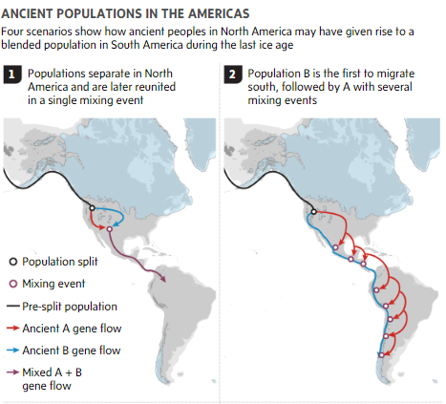
3
4

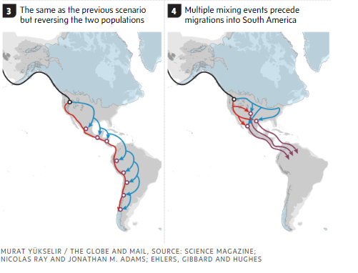

But the new study “shows there’s a much more complex history of interaction and migration that needs to be unravelled,” said Jay Stock, a team member at Western University in London, Ont.
Some of the ancient samples in the study were acquired with the help of Indigenous groups, including the Huron-Wendat First Nation in Canada. Those from the Windsor area were excavated from a burial site in the 1930s and have been housed at the University of Toronto ever since. Dr. Dewar said that one of the aims of the study is to better understand how the early inhabitants of the Great Lakes region relate to Indigenous people today.

