Trudeau graces the world stage as Canada has a moment.

Prime minister tells UN General Assembly that Canada is 'here to help'
By Aaron Wherry, CBC News Posted: Sep 20, 2016 9:00 PM ET Last Updated: Sep 20, 2016 9:00 PM ET
"Listen," Justin Trudeau said, nearing the end of his first address on the world's actual stage, "Canada is a modest country."
To demonstrate as much, he added three qualifiers for those before him at the United Nations General Assembly on Tuesday afternoon.
"We know we can't solve these problems alone," he said. "We know we need to do this all together. We know it will be hard work."
But then, a slightly immodest conclusion, a presumptive rallying cry that dares suggest we have something to offer the world.
"But we're Canadian," Trudeau declared, "and we're here to help."
With that, Trudeau seemed to invert Ronald Reagan's nine most terrifying words ("I'm from the government and I'm here to help"); the progressive standard-bearer of the moment tweaking the conservative icon's swipe at the utility of the state.
Taken at its most literal, Trudeau's offer might apply to meaningful action to reduce greenhouse gas emissions, funding for foreign aid and a new commitment to peacekeeping operations.
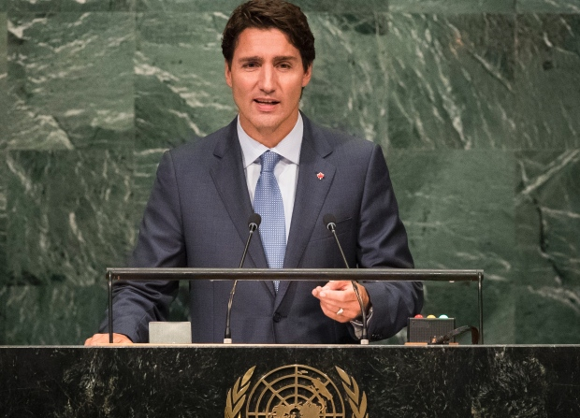
But then our humble outpost is presently noted for far more than mere contributions to UN activities. Now we have symbolic import.
Put on your finest denim jacket, for the world (or its press) is gazing upon us.

A model of liberalism and diversity?
We are emerging, to quote one dispatch, as "a champion of liberalism." Set against the ethnic anxieties and nationalism that has arisen in the United States and Europe, we are a model of diversity and integration.
Some of this is about the prime minister. For one, he is basically nice-looking and seems friendly. But also, as the BBC's Gavin Hewitt observed, Justin Trudeau "understands the power of small inclusive gestures."
The social media era magnifies both the outrageous and the inspiring and Trudeau is easily shareable: greeting refugees, celebrating gender equity, marching in Pride parades. And all of it contrasts perfectly to Donald Trump. (Which is not to diminish the importance of inclusive gestures.)
The story to that point writes itself.
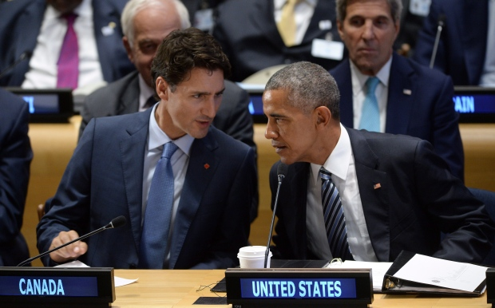
Prime Minister Justin Trudeau chats with U.S. President Barack Obama at the Leaders Summit on Refugees at the United Nations. (Sean Kilpatrick/Canadian Press)

Trudeau is also blessed to have inherited a mostly stable and sturdy country.
"Whether a man must be a friend or foe he knows that he must admit that there are today in Europe thousands and thousands of men who had never heard the name of Canada eight years ago and who today, every day, turn their eyes towards this new star which has appeared in the western sky," Wilfrid Laurier said in 1904, part of his declaration that the 20th century would belong to this country.
If Canada is experiencing something like that now, it's due in no small part to what occurred in the intervening 112 years.
We have been basically well governed. Our political institutions, whatever their shortcomings, have not fallen into wretched disrepair. Our public finances are not in crisis. Our economy was not as badly wounded as others by the most recent global recession.
We have fused together two linguistic cultures. And we have somehow come to accept and settle successive generations of immigrants.

'Not perfect, but right'
"In Canada, we got a very important thing right. Not perfect, but right," Trudeau told the United Nations. "In Canada, we see diversity as a source of strength, not weakness. Our country is strong not in spite of our differences, but because of them."
Whether by fate or by design, we have come to understand ourselves this way. Forty-three per cent of respondents to a recent Environics poll, for instance, said "multiculturalism" or "diversity" when asked what makes Canada unique.
If a nation is the story it tells itself, we might do well to re-read this bit on a regular basis.
We are perhaps lucky to have so far not suffered the crises or shocks that have tested other countries. As Andrew Coyne noted this week, it is a mere reality of our location that we have not experienced the rush of migrants that is felt in the Middle East and Europe or the illegal immigration that challenges the United States.
But, in the best-case scenario, our diversity has become a sort of self-fulfilling prophecy, or at least a built-in obstacle to anyone who would try to divide voters along simple condemnations of immigration.

The electoral imperative of new Canadians
At last report, 20 per cent of Canadians were born in other countries. Ahead of last year's election, Michael Adams of Environics and Andrew Griffith, a former official in the Citizenship Department, argued that the so-called "ethnic vote" was an "electoral imperative."
And that might explain why no prominent Conservative has yet lined up behind Kellie Leitch's proposed screening of immigrants for "anti-Canadian values."
"Let me put it this way, the Conservative Party cannot form a government unless it is doing very well, and I think ideally is the party of choice, amongst new Canadians and members of our cultural communities," Jason Kenney told the CBC's Rosemary Barton in an interview on Tuesday.
We can haggle over the political inclinations of various communities and polls might show support for values screening or banning the niqab, but we might hope that there is at least some built-in hesitancy to going down that path.
Our reflexive anti-Americanism might even make us mindful of trying to maintain some sense of moral superiority.
Complacency, of course, would be a rather immodest mistake.
Trudeau argues economic prosperity is the key, but others argue the troubles with immigration in other countries go much deeper than that. There is surely some responsibility to be conscious of existing and emerging anxieties and mindful of resettlement and integration patterns, not to mention stories of Syrian refugees using food banks.
To help the world on this front, Canada must remain a symbol by succeeding in practice.
In the meantime, we might act as a little pick-me-up in the world's Facebook feeds.

