Assignment #1: Graded Discussion
Come prepared to answer the following questions on Thursday, Sept. 21st
**You will be handing your prep in for marks – point form or paragraphs, your choice.

1. Explain the difference between the Beringia theory and the Coastal theory. Can they co-exist? What type of historical evidence is used to support each theory?
2. How do the theories of how Aboriginal Canadians arrived on the continent help to explain the diversity of prehistoric and historic Aboriginal nations?
3. Why do you think that until recently historians have largely ignored Aboriginal oral traditions (such as the creation myths) in the study of prehistoric Aboriginal history?

Assignment #2: Comparison of the First Peoples of North America
Using chapters 1 and 2 of your textbook as well as your notes, create a graphic organizer to differentiate and distinguish the Aboriginal Peoples of Canada studied in the first unit of this course. Your organizer should include such criteria as location, time period, social organization, governance, lifestyle, traditions, spirituality, and innovations.

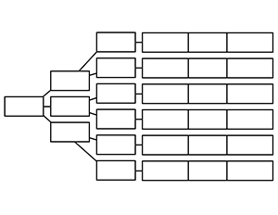
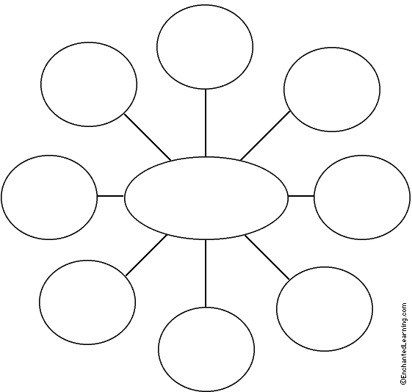

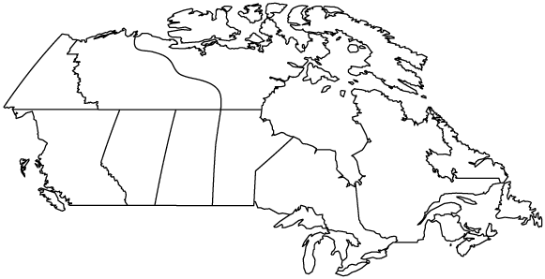

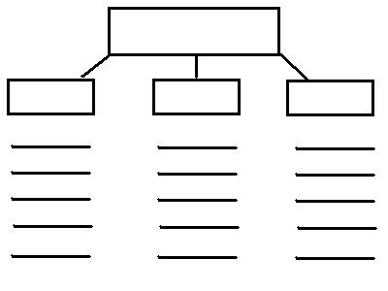

Due on Friday, September 29th

