Matter Quiz
Name: _____________________ Period: _____ Date: _______________

- Match the following definitions (12 marks)

  - Matter _____ A mixture of metals

  - Physical Change _____ iron reacts with oxygen to produce this

  - Chemical Change _____ Anything that has mass and takes up
space

  - Corrosion _____ compounds containing carbon and
hydrogen

  - Rust _____ the substance involved stays the same

  - Alloy _____ horizontal rows on the periodic table

  - Combustion _____ vertical columns on the periodic table

  - Hydrocarbon _____ a poisonous gas that is harmful to the
environment

  - Carbon Monoxide _____ the substance involved is changed into
another substance with different
properties

  - Mendeleev _____ a metal reacts with oxygen from the air

  - Group _____ a substance reacts rapidly with oxygen
and releases energy

  - Period _____ credited with the creation of the periodic
table

- Match each of the following words with their description: (9 marks)

  - Ductility _____ Thick flow of liquid

  - Solid _____ A can is bent when squeezed

  - Melting Point _____ How shiny or dull a substance is

  - Solubility _____ Copper can be stretched into wires

  - Density _____ Takes the shape of its container and has a
fixed volume

  - Malleability _____ The ability to dissolve salt in water

  - Viscosity _____ The amount of matter per unit volume

  - Lustre _____ It holds its shape and has a fixed volume

  - Liquid _____ The temperature at which a solid changes to a
liquid

- For each of the following state whether it is describing a Physical Change or a Chemical Change (8 marks)

  - _____________ Burning a log in the fire
  - _____________ Slicing a cucumber
  - _____________ Dissolving a sugar cube in water
  - _____________ Cooking a hot dog
  - _____________ Your ice cream melts in the sun
  - _____________ Bleaching your shirt to remove a stain
  - _____________ Some meat rots in the fridge
  - _____________ The puddle in your yard freezes overnight

- Label the following on the blank periodic table below (7 marks):

  - Metals
  - Nonmetals
  - Group of One (Hydrogen)
  - Alkali metals
  - Alkaline Earth Metals
  - Halogens
  - Noble Gases

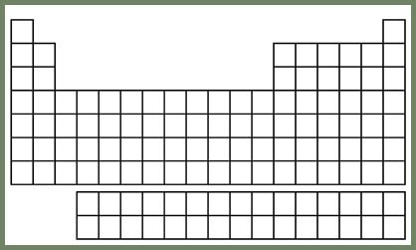

Total: 36 marks

