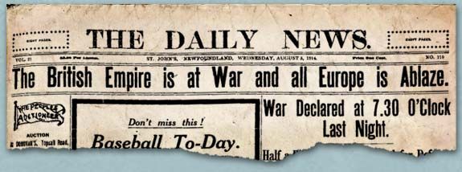

On the evening of August 4, 1914, Walter Davidson, the Governor of Newfoundland, received a cable informing him that Britain was at war. As a colony, Newfoundland and Labrador officially entered the war when Britain did. However, the exact role the colony would play was still to be determined. Davidson reacted quickly. On August 8, he wired London to say that Newfoundland and Labrador would raise five hundred men for land service and one thousand men for naval service.
Of all the battles that the Newfoundland Regiment fought during the First World War, none was as devastating or as defining as the first day of the Battle of the Somme. The Regiment's tragic advance at Beaumont Hamel on the morning of July 1, 1916 became an enduring symbol of its valour and of its terrible wartime sacrifices. The events of that day were forever seared into the cultural memory of the Newfoundland and Labrador people. While Canadians celebrate July 1st every year many Newfoundlanders observe Memorial Day – a sombre day of remembrance for those who paid the ultimate price while serving “King and Country”.
As part of a project that involves high school students across the country, we want to tell the stories of those young men who did not return home to Canada and are buried in cemeteries across Europe. Each student will be responsible for researching the military service records of one of the fallen soldiers. These files come from The Rooms, the Provincial Archives of Newfoundland and Labrador. Using the information contained in these records, and cross referencing it with information contained in battalion diaries, students will write a biography of their soldier’s life and service in war. Students will write a term paper for this course, which consists of two chapters. Chapter one will consist of the soldier biography and should be between 700 and 1000 words. Chapter two will extend to a topic related to the students’ interest that is borne out of the biography or research and should be 700 to 1000 words in length, as well. The due date for chapter one is Friday, November 10th and will account for half of the grade for the term paper assignment. The completed term paper (chapters one and two) is due no later than Friday, 9th December. A bibliography, and preferably, Chicago formatting with footnotes is also a requirement.

