The Quebec Conference
In October 1864, delegates from across British North America gathered in Quebec City to hammer out the terms of a union. A month earlier prominent politicians from the separate colonies of Nova Scotia, Prince Edward Island, New Brunswick, Newfoundland and Canada had met in Charlottetown and convinced each that it was in their best interest to create a federation.
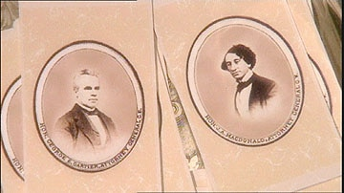
Calling cards (each about the size of a playing card) were quickly mass-produced for all the delegates of the Quebec Conference including George-Etienne Cartier (left) and John A. Macdonald (right). (As portrayed in Canada: A People's History)

The delegates at the Quebec Conference had the daunting task of spelling out the terms of Confederation.
Many of the politicians at the Quebec Conference were lawyers but others included doctors, businessmen and journalists. Of the 33 delegates in Quebec City, only four were French. The most powerful politician in Lower Canada, George-Étienne Cartier, preferred to have little help speaking for his fellow French Canadians.
"I never let public prejudice be my guide. I only consult, and will only ever consult my own conscience," Cartier once said.
The delegations from the Atlantic colonies included politicians from all persuasions as government members and rivals joined forces to protect their regional interests. Upper Canada's most prominent delegates included John A. Macdonald and George Brown. Most of the delegates stayed at the St. Louis Hotel, which was filled with railwaymen who took a keen interest in the negotiations. The railways had strong political ties supporting their schemes had already driven Canada, New Brunswick and Nova Scotia deep into debt.
If Confederation went through, the British government had promised to provide a large, low-cost loan, allowing the new nation to link up the separate lines in Nova Scotia, New Brunswick and Canada.

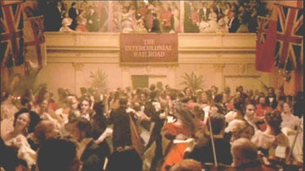
Railway interests were a strong presence at the Quebec Conference, sponsoring some of the lavish evening festivities. (As portrayed in Canada: A People's History)

The meetings at Quebec were held in secrecy. No press was allowed but notes were taken by delegates. The key concept of federalism - the idea that the central government would be granted certain powers while the provinces retained others - was molded into shape.
The Quebec Conference went on for three weeks dominated by debate and proposals during the day and parties at night. On October 14, there was a Delegates' Ball for 1,400 people held at Parliament House where they danced to the 25th Regiment's String band and dined on partridge, lobster salad and tongue. According to one account of the Ball, the evening began as a tableau of "grace, loveliness and politeness." But by four in the morning had descended into mayhem with the "supper floor covered with meat drink, and broken bottles."
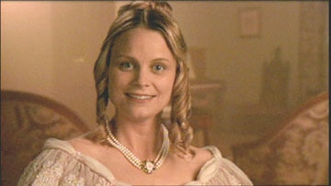
Mercy Coles was one of many family members who accompanied delegates to the Quebec Conference in October 1864. (As portrayed by Stephanie Morgenstern in Canada: A People's History)

After another ball, Feo Monck, the Governor General's sister-in-law, gleefully reported on Macdonald's erratic behaviour: "He is always drunk now, I am sorry to say, and when some one went to his room the other night, they found him in his night shirt, with a railway rug thrown over him, practicing Hamlet before a looking glass."
Despite the vigorous and eclectic social calendar, Macdonald did much of the actual work on the constitution, drafting 50 of 72 resolutions. He was the only one at the conference with a background in constitutional law. "As it is, I have no help," he told his friend Sir James Gowan. "Not one man of the conference (except Galt in finance) has the slightest idea of Constitution making. Whatever is good or ill in the Constitution is mine."
By the end of the Quebec Conference, a basic constitution had been drafted but not without dissent and dissatisfaction among some of the colonies.

