Thomas Malthus' "Essay on Population"

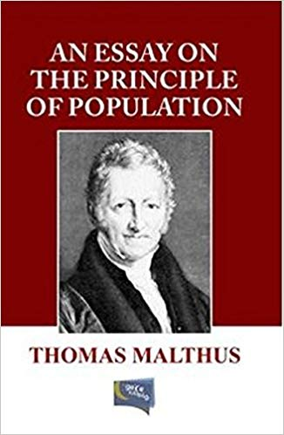
Marjie Bloy Ph.D., Research Fellow, National University of Singapore.
Thomas Malthus believed that natural rates of human reproduction, when unchecked, would lead to geometric increases in population: population would grow in a ratio of 2, 4, 8, 16, 32, 64 and so on. However, he believed that food production increased only in arithmetic progression: 2, 4, 6, 8, 10. It seemed obvious to him that something had to keep the population in check to prevent wholesale starvation. He said that there were two general kinds of checks that limited population growth: preventative checks and positive checks. Preventative checks reduced the birth rate; positive checks increased the death rate.
Moral restraint, vice and birth control were the primary preventative checks. Moral restraint was the means by which the higher ranks of humans limited their family size in order not to dissipate their wealth among larger numbers of heirs. For the lower ranks of humans, vice and birth control were the means by which their numbers could be limited - but Malthus believed that these were insufficient to limit the vast numbers of the poor.
The positive checks were famine, misery, plague and war; because preventative checks had not limited the numbers of the poor, Malthus thought that positive checks were essential to do that job. If positive checks were unsuccessful, then inevitably (he said), famine would be the resulting way of keeping the population down. Before starvation set in, Malthus advised that steps be taken to help the positive checks to do their work. He wrote:
It is an evident truth that, whatever may be the rate of increase in the means of subsistence, the increase in population must be limited by it, at least after the food has been divided into the smallest shares that will support life. All the children born, beyond what would be required to keep up the population to this level, must necessarily perish, unless room be made for them by the deaths of grown persons. ... To act consistently, therefore, we should facilitate, instead of foolishly and vainly endeavouring to impede, the operation of nature in producing this mortality, and if we dread the too frequent visitation of the horrid form of famine, we should sedulously encourage the other forms of destruction, which we compel nature to use.

Instead of recommending cleanliness to the poor, we should encourage contrary habits. In our towns we should make the streets narrower, crowd more people into the houses, and court the return of the plague. In the country we should build our villages near stagnant pools, and particularly encourage settlements in all marshy and unwholesome situations. But above all, we should reprobate specific remedies for ravaging diseases: and those benevolent, but much mistaken men, who have thought they were doing a service to mankind by projecting schemes for the total extirpation of particular disorders. If by these and similar means the annual mortality were increased ... we might probably every one of us marry at the age of puberty and yet few be absolutely starved.
In Malthus' opinion, the masses were incapable of exercising moral restraint, which was the only real remedy for the population problem (Malthus had eleven children). They were therefore doomed to live always at bare subsistence level. If all income and wealth were distributed among them, it would be totally wasted within one generation because of profligate behaviour and population growth, and they would be as poor and destitute as ever. Paternalistic attempts to help the poor were therefore highly likely to fail. Also, they were a positive evil because they drained wealth and income from the higher (and therefore more moral) ranks of society. These people were responsible - either in person or through patronage - for all the great achievements of society: art, music, philosophy, literature and so on owed their existence to the good taste and generosity of these people. Taking money from them to help the poor would deprive the world of culture.

